Assignment2

Niharika D

2022-10-26

library(dplyr)

##   
## Attaching package: 'dplyr'

## The following objects are masked from 'package:stats':  
##   
## filter, lag

## The following objects are masked from 'package:base':  
##   
## intersect, setdiff, setequal, union

Online_Retail<-read.csv("./Online_Retail.csv")  
head(Online_Retail)

## InvoiceNo StockCode Description Quantity  
## 1 536365 85123A WHITE HANGING HEART T-LIGHT HOLDER 6  
## 2 536365 71053 WHITE METAL LANTERN 6  
## 3 536365 84406B CREAM CUPID HEARTS COAT HANGER 8  
## 4 536365 84029G KNITTED UNION FLAG HOT WATER BOTTLE 6  
## 5 536365 84029E RED WOOLLY HOTTIE WHITE HEART. 6  
## 6 536365 22752 SET 7 BABUSHKA NESTING BOXES 2  
## InvoiceDate UnitPrice CustomerID Country  
## 1 12/1/2010 8:26 2.55 17850 United Kingdom  
## 2 12/1/2010 8:26 3.39 17850 United Kingdom  
## 3 12/1/2010 8:26 2.75 17850 United Kingdom  
## 4 12/1/2010 8:26 3.39 17850 United Kingdom  
## 5 12/1/2010 8:26 3.39 17850 United Kingdom  
## 6 12/1/2010 8:26 7.65 17850 United Kingdom

#1  
trans_countries<-Online_Retail %>% group_by(Country) %>% summarise(cnt = n()) %>% mutate(perc =round((cnt/sum(cnt))*100,5)) %>% filter(perc>1)  
View(trans_countries)

#2  
TransactionValue<-Online_Retail$Quantity*Online_Retail$UnitPrice  
  
#creating a dataframe  
  
Online_Retail_new<-data.frame(InvoiceNo=Online_Retail$InvoiceNo,StockCode= Online_Retail$StockCode,Description=Online_Retail$Description,Quantity=Online_Retail$Quantity, InvoiceDate=Online_Retail$InvoiceDate,UnitPrice=Online_Retail$UnitPrice, CustomerID=Online_Retail$CustomerID,Country=Online_Retail$Country, TransactionValue=TransactionValue)  
  
  
head(Online_Retail_new)

## InvoiceNo StockCode Description Quantity  
## 1 536365 85123A WHITE HANGING HEART T-LIGHT HOLDER 6  
## 2 536365 71053 WHITE METAL LANTERN 6  
## 3 536365 84406B CREAM CUPID HEARTS COAT HANGER 8  
## 4 536365 84029G KNITTED UNION FLAG HOT WATER BOTTLE 6  
## 5 536365 84029E RED WOOLLY HOTTIE WHITE HEART. 6  
## 6 536365 22752 SET 7 BABUSHKA NESTING BOXES 2  
## InvoiceDate UnitPrice CustomerID Country TransactionValue  
## 1 12/1/2010 8:26 2.55 17850 United Kingdom 15.30  
## 2 12/1/2010 8:26 3.39 17850 United Kingdom 20.34  
## 3 12/1/2010 8:26 2.75 17850 United Kingdom 22.00  
## 4 12/1/2010 8:26 3.39 17850 United Kingdom 20.34  
## 5 12/1/2010 8:26 3.39 17850 United Kingdom 20.34  
## 6 12/1/2010 8:26 7.65 17850 United Kingdom 15.30

#3  
Trans_value_countries<- Online_Retail_new %>% group_by(Country) %>% summarise(sum_TransactionValue = sum(TransactionValue)) %>% filter(sum_TransactionValue>130000)  
  
View(Trans_value_countries)

##5  
  
  
histogram<- Online_Retail_new %>% filter(Country == 'Germany')   
numeric_TV<- as.integer(histogram$TransactionValue)  
hist(numeric_TV)

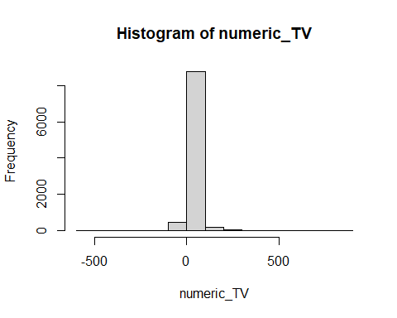

##6  
  
cust_count<-Online_Retail_new %>% group_by(CustomerID) %>% summarise(cntt = n()) %>% arrange(desc(cntt))  
View(cust_count)  
  
#Customer 17841 has the highest number of transactions.  
  
cust_sum<-Online_Retail_new %>% group_by(CustomerID) %>% summarise(sum_cnt =sum(TransactionValue)) %>% arrange(desc(sum_cnt))  
  
View(cust_sum)  
  
#Customer 14646 is the most valuable

#7  
  
missing_values<- (colMeans(is.na(Online_Retail_new))*100)  
  
View(missing_values)

#8  
missing<-Online_Retail_new %>% filter(is.na(CustomerID)) %>% group_by(Country) %>% summarise(Countries = n())  
  
View(missing)

#9

#10  
return_rate <- Online_Retail_new %>% filter(Country=='France')  
cancelled_customers <- nrow(subset(return_rate,TransactionValue<0))  
View(cancelled_customers)  
  
return_rate_french_cust=(cancelled_customers/8556)  
  
View(return_rate_french_cust)

##11  
item_sum<-Online_Retail_new %>% group_by(Description) %>% summarise(sum_cnt = sum(TransactionValue)) %>% arrange(desc(sum_cnt))  
View(item_sum)  
  
#DOTCOM POSTAGE generates highest revenue for the retailer

##12  
  
xx<- Online_Retail_new %>% distinct(CustomerID) %>% summarise(ncount = n())  
View(xx)